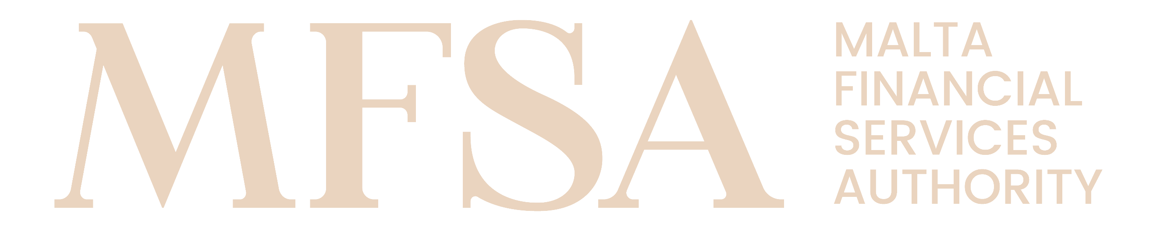
MALTA FINANCIAL SERVICES AUTHORITY
Authorisation Forms - Annex

Annex AX30: Table 3 - Application for a permission to operate a DLT MTF or DLT TSS: Exemption(s) to Directive 2014/65/EU and Regulation (EU) No 600/2014
High Level Guidelines
- General

This form, Annex AX30: Table 3 - Application for a permission to operate a DLT MTF or DLT TSS: Exemption(s) to Directive 2014/65/EU and Regulation (EU) No 600/2014 (‘Annex’), shall be duly filled in by persons wishing to obtain authorisation from the MFSA to carry out financial services activities. This Annex shall be submitted as part of and in conjunction with the relevant Authorisation Application Form, as indicated therein.

This Annex primarily aims to capture relevant information in relation to the permission to operate a DLT Market Infrastructure.

According to Article 8(4)(h) of Regulation (EU) 2022/858 the application for a specific permission to operate a DLT MTF shall contain information on the exemptions that the applicant is requesting in accordance with Article 4 of that same Regulation, the justification for each exemption requested and any compensatory measures proposed and the means by which it intends to comply with the conditions attached to those exemptions.

Please refer to Article 4 of Regulation (EU) 2022/858 for the specific conditions attached to each exemption. According to Article 4(4) of Regulation (EU) 2022/858, the applicant shall demonstrate that each exemption requested is:
- proportionate to, and justified by, the use of distributed ledger technology; and
- limited to the DLT MTF and does not extend to any other multilateral trading facility operated by that applicant.

In this respect, the Applicant shall to the best of its knowledge, provide information, which is truthful, accurate and complete. The Applicant shall notify the MFSA immediately if the information provided changes in any material respect either prior to or subsequent to authorisation.

The Applicant is required to make reference, and where applicable comply with, the relevant Act, the Regulations made, or Rules issued thereunder during the completion of the Application. The Applicant shall also refer to the respective National and/or European Regulatory Frameworks or other binding regulation as may be applicable.

The Applicant shall not tamper with, or modify in any manner, this Annex or its respective Application. Should it transpire that the documents were tampered with, or modified in any manner, the Authority shall consider the submission to be invalid. Any potential improvements should be communicated to the MFSA for consideration.

The Authority may at its sole discretion request from the Applicant further information/ documentation.

- Definitions

Unless otherwise specified, terms used in this Annex shall have the same meaning assigned to them within the respective Application.

- Instructions

In order for this Annex to be considered complete, the Applicant is required to complete all the respective sections under this Annex. It is noted that the information provided should reflect the Applicant’s structure and method of operations at time of authorisation.

- Privacy Notice

The MFSA ensures that any processing of personal data is conducted in accordance with Regulation (EU) 2016/679 (General Data Protection Regulation), the Data Protection Act (Chapter 586 of the Laws of Malta) and any other relevant European Union and national law. For further details, you may refer to the MFSA Privacy Notice available on the MFSA webpage https://www.mfsa.mt/privacy-notice/.

- Applicant Details
 | Applicant – Identification Details
 | Registered Name | Enter text
 | Registered Number | Enter text
 | LEI Code  (if applicable) | Enter text

- Exemption requested
Direct Retail Participation
Article 53(3) and 19(2) of Directive 2014/65/EU
 | Direct Retail Participation | Select item
Short justification, compensatory measures proposed (if any) and means by which conditions attached to
exemptions are complied with.
 | Enter text
 | Demonstration that the exemption is proportionate and justified by the use of the DLT
 | Enter text
 | Demonstration that the exemption is limited to the DLT MTF and does not extend to any other MTF operated by the applicant
 | Enter text
 | Unique reference number of the document, Title, Chapter or section or page where the information is provided or reason why the information is not provided.
 | Enter text
Transaction reporting
Article 26 of Regulation (EU) No 600/2014
 | Transaction reporting | Select item
Short justification, compensatory measures proposed (if any) and means by which conditions attached to
exemptions are complied with.
 | Enter text
 | Demonstration that the exemption is proportionate and justified by the use of the DLT
 | Enter text
 | Demonstration that the exemption is limited to the DLT MTF and does not extend to any other MTF operated by the applicant
 | Enter text
 | Unique reference number of the document, Title, Chapter or section or page where the information is provided or reason why the information is not provided.
 | Enter text

