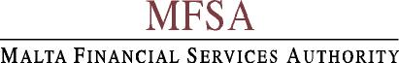

Appointment of Insurance Brokers

The Board of Governors of the Malta Financial Services Authority (the “MFSA”) invites applications from interested parties who are licensed to provide insurance broking services. The appointed firm will be expected to assist in reviewing the current insurance programme of the Authority, acquire quotations, carry out risk evaluations and report to the MFSA as appropriate.

Interested parties are invited to express their interest in accordance with the terms and conditions laid out in the Tender Document by 12 noon on 14th March 2005. Tender documents outlining the MFSA’s requirements for this service may be collected from our offices at the address below between 8.30 and 17.00 hrs, Monday to Friday, against a nominal payment of Lm10.

The Malta Financial Services Authority
Notabile Road
Attard BKR 14

All submissions will be the treated in the strictest confidence. The MFSA reserves the right to refuse even the most advantageous offer and may award tender either in whole or in part.

