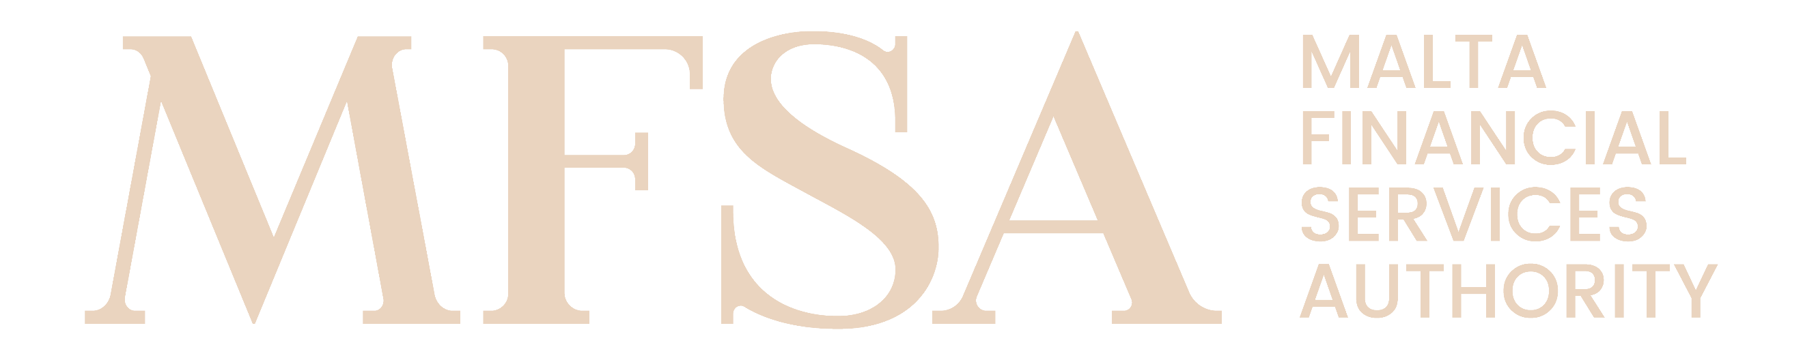
MALTA FINANCIAL SERVICES AUTHORITY
NAIF Notification Form – Annex III

AIFM self-certification

Name of the NAIF: Enter text
Name of the AIFM: Enter text

We, the governing body of the AIFM, hereby confirm that the AIFM possesses the adequate knowledge, skills and experience to serve as the AIFM to the NAIF, and to discharge, or monitor effectively its delegate’s discharge of, the responsibilities allocated to it.

We hereby confirm that the AIFM itself or through its advisers and/or its delegate(s) has an appropriate degree of knowledge and understanding of the assets in which the NAIF invests, and the AIFM and/or its delegate(s) has/have the expertise, knowledge, and skill to manage the NAIF in accordance with the objectives, investment strategy and risk limits set out in the prospectus for the NAIF.

We hereby confirm compliance with the provisions of the Investment Services Act (List of Notified AIFs) Regulations and of the Investment Services Rules for Notified Alternative Investment Funds.

Signature of the official authorised to sign on behalf of the AIFM
Name | Enter text | Surname | Enter text
Position | Enter text
Date | Enter date
(Add multiple as applicable)

