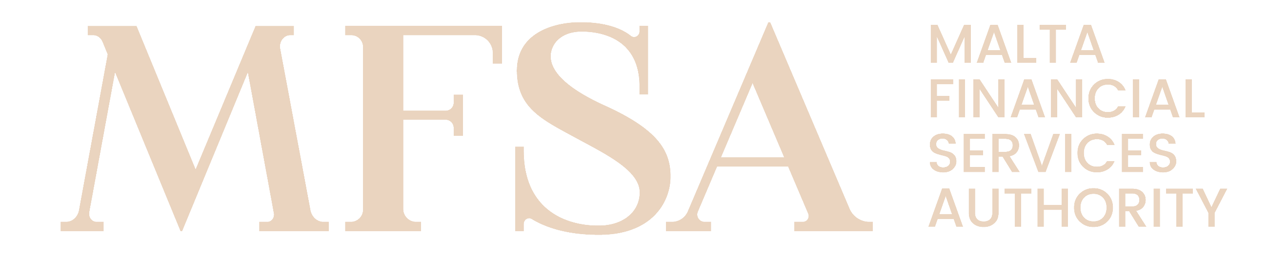
MALTA FINANCIAL SERVICES AUTHORITY
NAIF Notification Form – Annex V

Declaration Form for AIFM regarding due diligence undertaken on the NAIF’s service providers and governing body

Name of the NAIF: Enter text
Name of the AIFM: Enter text

We, the governing body of the AIFM, hereby confirm that:
- the AIFM has carried out due diligence on the Select item of the NAIF. We hereby confirm that the AIFM is satisfied that the Select item of the NAIF comply with the standards of fitness and properness required by the MFSA in the Investment Services Act (List of Notified AIFs) Regulations and the Investment Services Rules for Notified Alternative Investment Funds, and that the AIFM shall notify the MFSA should such individual(s)/entity(ies) cease to comply with the mentioned standards;
- each service provider appointed by the AIFM, in respect of the NAIF, was selected with all due care and subject to appropriate due diligence; is competent, qualified and capable of undertaking the functions for which it is appointed; and complies with the high level of fitness and properness required by the MFSA. We hereby confirm that the AIFM shall notify the MFSA should such service provider/s cease to comply with the mentioned standards;
- the AIFM is satisfied with the outcome of this due diligence exercise and that there are no untoward features with regard to any of the appointed service providers or members of the governing body of the NAIF;
- all due diligence exercise undertaken have been fully documented and are available for inspection by the MFSA at the offices of the AIFM; and
- the due diligence exercise carried out will be updated at periodical intervals and the updates will be documented and will be made available for inspection by the MFSA at the offices of the AIFM.

Signature of the official authorised to sign on behalf of the AIFM
Name | Enter text | Surname | Enter text
Position | Enter text
Date | Enter date
(Add multiple as applicable)

